Mobile Apps Every Library Staffer Needs
- First, basic Privacy and Security
  - Set a screen lock
  - Make sure your data is backed up
  - Encrypt your device
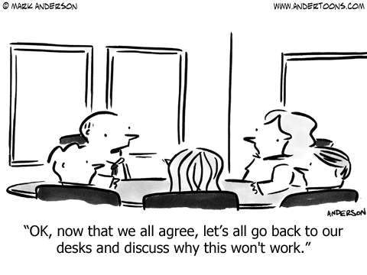
  - Turn on 2-factor authentication
  - Only download from a trusted source
  - If the device is Lost or Stolen
    - Use iCloud/Find My iPhone for Apple
    - Android Device Manager for Others
- Anonymous Communication
  - www.torproject.org (android)
  - https://mike.tig.as/onionbrowser/ (iOS devices)
  - https://www.ghostery.com)
  - https://www.duckduckgo.com
- Password managers
  - https://lastpass.com
  - https://agilebits.com/onepassword
- Email
  - http://www.google.com/inbox
  - https://cloudmagic.com
- Productivity
  - www.ifttt.com
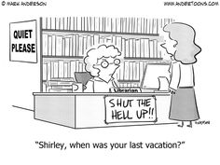
  - www.papershipapp.com
    - https://www.mendeley.com
    - https://www.zotero.org
  - https://getpocket.com/
- Maps and Transport
  - www.citymaps.com
  - https://citymapper.com
- Image and Music Recognition Search
  - www.camfindapp.com
  - www.soundhound.com
- Fast Facts and Ready Reference
  - http://wilmingtondowntownapp.com
  - www.allmusic.com
  - www.wolframalpha.com
  - www.apps.worldbank.org
  - www.unric/en/apps-directory
  - www.gpo.gov/mobile
  - www.census.gov/mobile
  - https://www.usa.gov/mobile-apps
  - Congressional Data (Android and iOS separate)
    - https://play.google.com/store/apps/details?id=com.sunlightlabs.android.congress&hl=en
    - https://itunes.apple.com/us/app/in-congress-us-congress-dashboard/id894764351?mt=8

- Cool and Useful
  - https://translate.google.com
  - https://photomath.net
- News and Information
  - https://itunes.apple.com/us/app/newspapers-for-ipad/id364745388
  - https://itunes.apple.com/us/app/city-papers/id497263176?mt=8
  - http://emm.newsbrief.eu/NewsBrief/clusteredition/en/latest.html
  - https://itunes.apple.com/us/app/newsalert/id312578432?mt=8
  - https://www.owler.com/
- Other Goodies
  - www.twerkerapp.com
  - http://www.flightradar24.com/apps
  - http://www.marinetraffic.com/en/p/mobile

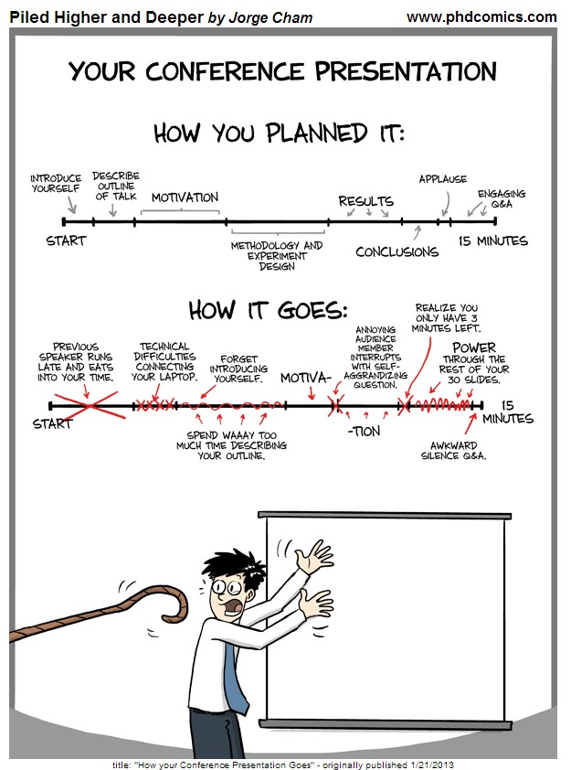
This session is based on a workshop presented by Gary Price, co-founder of Library Journal’s INFODocket and Full Text Reports. The workshop, “30 Mobile Apps for Librarians in 40 Minutes” was presented at the 2015 Computers in Libraries Conference.

Bryson Kopf, Librarian I
CCPL&IC, Spring Lake Branch
bkopf@cumberland.lib.nc.us
910.483.7727 ext. 1463

Sana Moulder, Library Associate
CCPL&IC, Local & State History
smoulder@cumberland.lib.nc.us
910.483.7727 ext. 1363

